# Replication of Jacowitz & Kahneman’s (1995) Experiment in Anchoring

Violet Henriques*, Alex McVickar*, Abeerah Qureshi*, BC Reale, Cassidy Walker, Sasha Wolf-Powers, Lily Johnson, Isacc Bennett, Atalanta Bella-Rogol, Amelia Hooks, Arreanna Jones-Ducharme, Emma Norman, Aaron Shpungin Lyubansky, Katie Rowan, Claire Guillemin, Karah Thomas, Kalah Thomas, Lakeland Menadue, Anna Bogler, Shanna Deng, Isaac Rubin, Ambar L. Hart González, Tziporah Rebbeck

*Hampshire College*

*Joint First Authors

## Abstract

This is a conceptual replication of [Jacowitz & Kahneman’s](http://facweb.plattsburgh.edu/wendy.braje/students/psy205/JKarticle.pdf) “Measures of Anchoring in Estimation Tasks” (1995). The original survey involved participants giving different estimates for varying questions, each with an “anchor,” a number providing a predetermined percentile. Interestingly, when presented with this anchor figure, people will likely answer closer to it - testing if anchoring is an influential phenomenon. We tested our hypothesis by using the same questions from the original study (as well as additional Hampshire-specific questions) and creating an online version. After asking participants to complete the questionnaire, we discovered that anchoring heavily influenced their responses depending on which anchor they were presented with initially. We found that those with high anchors tended to give higher answers than those with low anchors; however, the medians of our data more consistently showed this than the means due to the presence of outliers.

## Introduction

People often underestimate the power of the first piece of information they receive, a cognitive bias known as anchoring bias ([Tversky & Kahneman, 1974](https://www.science.org/doi/abs/10.1126/science.185.4157.1124)). Simply, it describes the tendency for initial observations or judgments of a person or situation to influence the ones made later. This phenomenon follows a curvilinear relationship regarding anchor distance, meaning moderate anchors typically produce the most substantial effects compared to excessively high or low ones ([Mussweiler & Strack, 2001](https://guilfordjournals.com/doi/abs/10.1521/soco.19.2.145.20705)). Furthermore, research has shown that setting an anchor above the correct answer generates a more pronounced skew than one below said value ([Jacowitz & Kahneman, 1995](http://facweb.plattsburgh.edu/wendy.braje/students/psy205/JKarticle.pdf)).

In our replication, we combined elements of two studies, creating a composite of the parameters tracked and data sets collected. To consider the statistical implications, we adjusted for discrepancies in the type of measurements taken and variables considered within specific contexts. Adjusting for such nuances enabled us to reach meaningful conclusions from our findings, increasing what can be extrapolated from the collective studies.

In *Measures of Anchoring in Estimation Tasks*, published in 1995, [Karen E. Jacowitz and Daniel Kahneman](http://facweb.plattsburgh.edu/wendy.braje/students/psy205/JKarticle.pdf) studied the effects of anchoring on estimation tasks. The study involved 156 University of California, Berkeley students who completed a questionnaire for their course requirements. They divided participants into a calibration group of 53 participants and an experimental/anchored group of 103 participants. Two anchors were set: a low anchor at the 15th percentile and a high anchor at the 85th percentile of the calibration group’s distribution.The results showed that the anchoring effect was significant for most of the 15 questions. The mean anchoring index for all 15 problems was 0.49, showing that the median subject moved nearly halfway to the anchor from the estimate they would have made without it. Additionally, high anchors were found to be more effective than low anchors.

[Klein et al. (2014)](https://psycnet.apa.org/fulltext/2014-20922-002.html) replicated this study as part of a Many Labs replication of 13 psychological effects. In their replication of the anchoring study, the survey contained four questions used in the original study but did not include the question about confidence. Additionally, participants were told that the number was either higher or lower than the anchor rather than being instructed to guess. The results showed that the anchoring effect was one of the strongest effects of 13 total replications.

## Methods

We decided to do a conceptual replication rather than a direct one. The first four questions we used for our replication were from the original survey by [Jacowitz & Kahneman (1995)](http://facweb.plattsburgh.edu/wendy.braje/students/psy205/JKarticle.pdf) that were also used in the ManyLabs replication ([Klein et al., 2014](https://psycnet.apa.org/fulltext/2014-20922-002.html); [Klein et al. materials](https://osf.io/tjx3f)). Additionally, we included the question about Lincoln’s presidency from the original study because it had almost no anchoring effect.

The final three questions we included in our survey were new ones we designed to be more relevant to our participants in the Hampshire College community. When the designed questions were written, we wrote them simply and with similar diction to the questions from the original study.

For the first five questions, we used the anchors from the original study by [Jacowitz & Kahneman (1995)](http://facweb.plattsburgh.edu/wendy.braje/students/psy205/JKarticle.pdf). The reason was to ensure further that the participants were clear when answering the questions, possibly causing more outliers in the data. We used a control survey to get anchors for the new questions, which we shared with the Hampshire college community via digital communication. We used the 85th and 15th percentiles of the data from this survey to make the “more than” and “less than” anchors, respectively.

The final survey had eight anchoring topics and sixteen main questions listed in Appendix I. Participants were randomly assigned to either the high or low anchor for each question. For each anchoring topic, participants were first asked whether they believed the answer to the question was higher or lower than the anchor, and they were then asked to state what they believed the correct answer to be. The survey was distributed through word-of-mouth, social media, and flyers with QR codes around campus. Unfortunately, we did not explain the survey’s purpose to our subjects.

## Results

Our survey yielded responses from 94 individuals in total. Of those who participated, 58 were currently enrolled as students at Hampshire College, 27 respondents identified as family or friends of Hampshire College students, and three reported that they were alumni of the institution. One was a student/faculty/staff from another one of the Five Colleges. Other participants selected the response “other” when asked if they were actively affiliated with Hampshire College. (Figure 1.0)

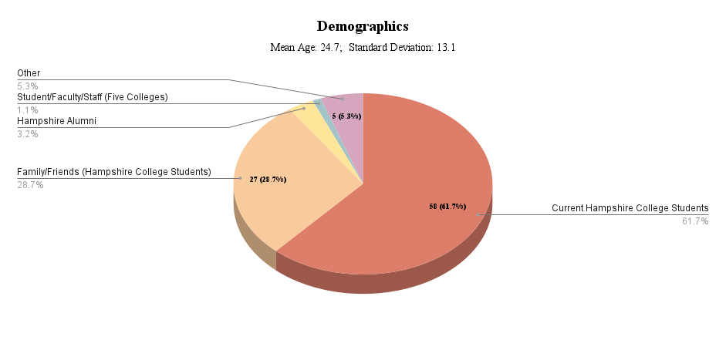  
Figure 1.0: Pie Chart of Demographics

A sharp distinction between generations is seen to be represented within the respondents; their average age was 24.7 years, with a standard deviation of 13.1 years.

After running our analysis, we took note of the median figures. These numbers stood out to us more than others because they were less prone to anomalies like outliers. In other words, the median was producing results with more accuracy and providing more telling answers considering the presence of unusually high or low values in our dataset. This insight helped to garner a better understanding of the overall narrative that our data wanted to tell.

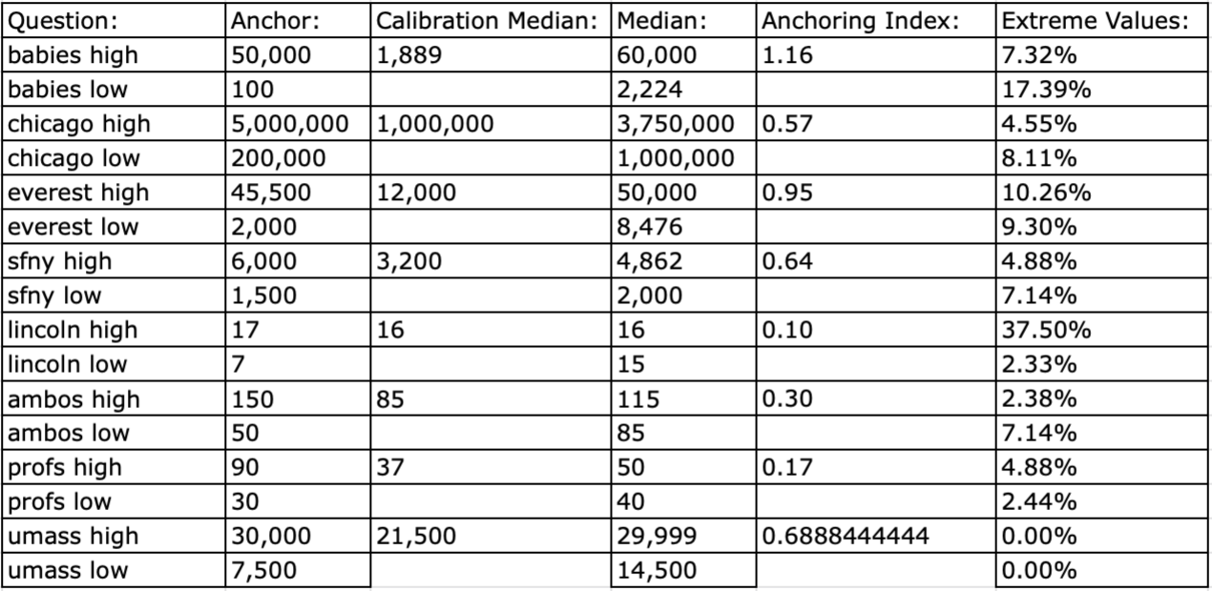Table 1.0: Results

Table 1 displays our inquiry and its corresponding anchor values, calibration median, (observed) median, anchoring index, and the amount of extraordinary figures. This data was included in [Jacowitz & Kahneman's](http://facweb.plattsburgh.edu/wendy.braje/students/psy205/JKarticle.pdf) initial 1995 study, although we omitted their "Transformed Median" due to not being able to decipher which formula they used for transformation.

The given formula defines the anchoring index (AI).

AI = $\frac{median\left(highanchor\right)−median\left(lowanchor\right)}{highanchor−lowanchor}$

This articulates the total anchoring effect with 0 being no effect. Almost all of our questions had a sizable AI, with only the Lincoln question, and the professor question being below 0.20. Figure 1 (below) shows the AI of all the questions we asked. Furthermore, our AI for babies was higher than any AI in [Jacowitz & Kahneman’s](http://facweb.plattsburgh.edu/wendy.braje/students/psy205/JKarticle.pdf) original study. All of this suggests that anchoring not only replicates consistently, but that there are unknown factors that cause anchoring’s potency to vary. These theories merit investigating.

We choose to include the Lincoln question because, in J[acowitz & Kahneman’s](http://facweb.plattsburgh.edu/wendy.braje/students/psy205/JKarticle.pdf) original study, it had an AI of 0. Our study gave it an AI of 0.10 which is quite close. Also notable is that the professor question had an AI of 0.17. Our hypothesis suggests that prior knowledge has an adverse influence on anchoring effectiveness. Our analysis corroborated this, where we found that current Hampshire students were less influenced by anchoring than other groups. Comparing the two anchor indexes supports this statement: 0.21 for current students (61.7%) versus 0.47 for other groups (38.3%).

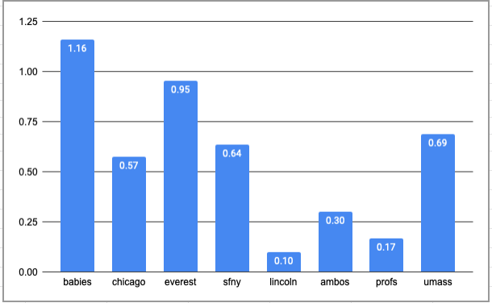

Figure 2.0: Anchoring index for each question

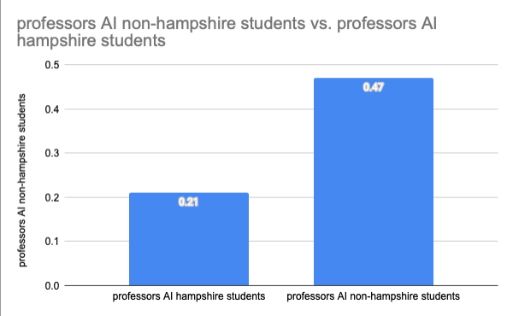

Figure 3.0: “Professors” AI non-Hampshire students vs. “Professors” AI Hampshire students

## Conclusion

This study demonstrated that anchoring often affects the respondent’s estimates depending on whether they were given the high or low anchor. We also found that the medians of our data tended to show the effects of anchoring than the means more consistently. The medians in all eight questions show that those with high anchors gave higher answers, while only five of the questions show this when looking at the means; the means for the questions about babies, Everest, and San Francisco-New York show that those with the high anchor gave lower answers than those with the low anchor. This is likely due to the presence of some outliers that skewed the low anchor means. If the outliers were removed from the calculation of the means, the anchoring effect would likely be seen in these questions as well.

One possible limitation of our study is that most of our participants were Hampshire College students, which could have influenced the strength of the anchoring effect for the last three questions (AMBOS, Profs, and UMass) since they more likely had prior knowledge of the information asked about; however, interestingly, the effects of anchoring can still be seen. Therefore, testing these questions on a different population could be beneficial to see if the anchoring effect is more substantial for those without prior knowledge.

To summarize, our research has illuminated that anchoring is a pervasive occurrence that can be replicated and analyzed with different degrees of success based on contextual factors. In addition, we have discerned that elements such as prior knowledge or experiences play an integral role in influencing the anchoring effect’s efficacy. If practitioners consider these elements when using this cognitive bias, their likelihood of achieving desired results increases significantly.

Through examination, this report provides evidence of anchoring’s influence depending upon the context. Our findings demonstrate that an anchor’s impact can change drastically in different settings, and it is essential to consider any external pressures when attempting to utilize this psychological tactic. More research needs to be conducted if we are going to fully understand the nuances of anchoring & its effects across various situations.

Ultimately, our research findings offer a valuable perspective for those working in cognitive science and bias manipulation. Practitioners can use this data to understand better how anchoring affects decision-making processes.

**Author Contribution Statement**

BC.R. Abstract.

A.Q. Abstract, Introduction, Citation & References, Editing, Conclusion, Recruitment, Demographics (Figure 1.0), Data Analysis, Group Discussion

E.N. Introduction, Survey, recruited participants

C.M.W. Methods, Appendix, Calibration Survey, designed materials, recruited participants.

I.M.B. Methods

A.B. Methods, Results, Introduction, recruited participants

V.M. Results, Spreadsheets, Data Analysis

A.M. Calibration Survey, Recruited Participants, Results Table/Data Analysis,

C.G. Spreadsheets/Data Analysis, Methods, Table Analysis

S.W.P. Suggestions and Edits

A.H Group discussion, recruited participants

L.M. Suggestions, Group Discussion, Recruited Participants

A.C.J.D. Abstract, Methods, recruited participants

K.R. Abstract, Conclusion, References/Citations, Editing, Recruited Participants

A.S.L. Group Discussion Suggestions, Question Formation, Recruited Participants

A.O. Group Discussion, Spreadsheets/Data Analysis

K.T. Recruit Participants, Group discussion

K.A.T. Recruit Participants, Group discussion

I.R, A.L.H.G., T.R. and E.L.-P. supervised the project.

## References

Jacowitz, K. E., & Kahneman, D. (1995). Measures of anchoring in estimation tasks. *Personality and Social Psychology Bulletin*, *21*(11), 1161-1166. <https://doi.org/10.1177/01461672952111004>

Klein, R. A., Ratliff, K. A., Vianello, M., Adams Jr, R. B., Bahník, Š., Bernstein, M. J., ... & Nosek, B. A. (2014). Investigating variation in replicability: A “many labs” replication project. *Social Psychology*, *45*(3), 142-152. <https://doi.org/10.1027/1864-9335/a000178>

Klein, R. A., Ratliff, K. A., Nosek, B. A., Vianello, M., Pilati, R., Devos, T., … Kappes, H. B. (2022). Methods and Study Materials. <https://doi.org/10.17605/OSF.IO/S7XQ3>

Mussweiler, T., & Strack, F. (2001). Considering the impossible: Explaining the effects of implausible anchors. Social Cognition, 19(2), 145-160. [https://doi.org/10.1521/soco.19.2.145.20705](https://psycnet.apa.org/doi/10.1521/soco.19.2.145.20705)

Tversky, A., & Kahneman, D. (1974). Judgment under uncertainty: Heuristics and biases. Science, 185(4157), 1124-1131. <https://www.jstor.org/stable/1738360>

## 

## Appendix I

Link to survey: <https://hampshire.co1.qualtrics.com/jfe/form/SV_eQFwJV5I7m7pt4>.

1. Consent Form
2. Age Check - I affirm that I am 18 years of age or older.
3. Instructions
4. **BABIES**
   1. Babies high
      1. Are more or less than 50,000 babies born per day in the United States?
      2. How many babies do you think are born in the United States each day?
   2. Babies low
      1. Are more or less than 100 babies born per day in the United States?
      2. How many babies do you think are born in the United States each day?
5. **CHICAGO**
   1. Chicago high
      1. Is the population of Chicago higher or lower than 5,000,000?
      2. What do you think the population of Chicago is?
   2. Chicago low
      1. Is the population of Chicago higher or lower than 200,000?
      2. What do you think the population of Chicago is?
6. **EVEREST**
   1. Everest high
      1. Is Mount Everest shorter or taller than 45,500 feet?
      2. How tall do you think Mount Everest is (in feet)?
   2. Everest low
      1. Is Mount Everest shorter or taller than 2,000 feet?
      2. How tall do you think Mount Everest is (in feet)?
7. **SFNY**
   1. SFNY high
      1. Is the distance from San Francisco to New York City shorter or longer than 6,000 miles?
      2. How far do you think San Francisco is from New York City (in miles)?
   2. SFNY low
      1. Is the distance from San Francisco to New York City shorter or longer than 1,500 miles?
      2. How far do you think San Francisco is from New York City (in miles)?
8. **LINCOLN**
   1. Lincoln high
      1. Was Lincoln's presidency before or after the 17th presidency?
      2. What number do you think Lincoln's presidency was?
   2. Lincoln low
      1. Was Lincoln's presidency before or after the 7th presidency?
      2. What number do you think Lincoln's presidency was?
9. **AMBOS**
   1. AMBOS high
      1. Is the distance between Amherst and Boston more or less than 150 miles?
      2. What do you think the distance is between Amherst and Boston (in miles)?
   2. AMBOS low
      1. Is the distance between Amherst and Boston more or less than 50 miles?
      2. What do you think the distance is between Amherst and Boston (in miles)?
10. **PROFS**
    1. Profs high
       1. Are there more or fewer than 90 professors at Hampshire College?
       2. How many professors do you think are at Hampshire College?
    2. Profs low
       1. Are there more or fewer than 30 professors at Hampshire College?
       2. How many professors do you think are at Hampshire College?
11. **UMASS**
    1. UMass high
       1. Are there more or fewer than 30,000 students at UMASS Amherst?
       2. How many students do you think are at UMASS Amherst?
    2. UMass low
       1. Are there more or fewer than 7,500 students at UMASS Amherst?
       2. How many students do you think are at UMASS Amherst?
12. Previous survey - Did you take the previous survey from this class? (if you don't know, answer "no")
13. Hamp student
    1. Check whatever applies:
    2. I am a current Hampshire student
    3. I am an alum of Hampshire College
    4. I am faculty/staff at Hampshire College
    5. I am family or friend of a Hampshire College student
    6. I am student/faculty/staff at another Five College
    7. Other: [text entry]
14. Age - How old are you?
15. Free response - Anything you want to share with us about the survey?

## Appendix II

**Alternate Version of Table 1** **with Mean**

